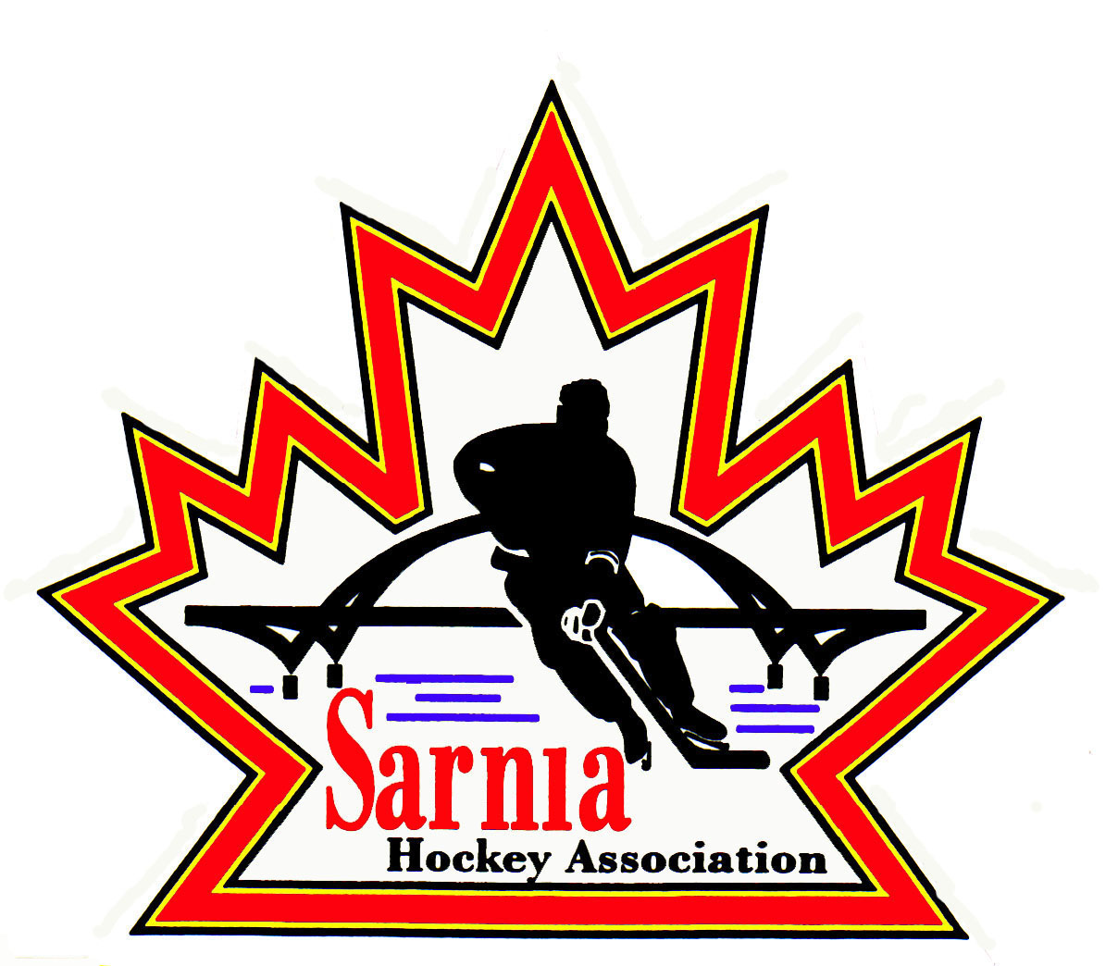

Sarnia Hockey Association

Minutes | Date: APRIL 24, 2024 | time 7:00 pm

Meeting called by | Paul Walsh, Chairperson
Type of meeting | Regular
Secretary | Barb Walsh, Acting Recording Secretary

Welcome | Paul Walsh, Chair welcomed everyone and called the meeting to order at 7:05 pm.

ATTENDANCE | Andrew Beasley, Jerry Bernardo, Alister Brown, Emily Brown, Harry Chadwick, Ian Dunn, Chuck Ewart, Jeff Fogal, David Penner, Pat Forbes, Kevin Taylor, Barb Walsh, Paul Walsh  Regrets: Terry Gray, Kelly Lane, Don McGugan, Jacquie Beasley, Lesley Taylor-Smith, Darren Chevalier, John Mellor, Kyle Mellor, Ted Pendle, Wayne Scarrow  Guests: John Ritchie, Tyson Ellwood, Melissa Forbes, Brent Campbell, Sue Weltz

ACCEPTANCE OF MINUTES | MOTION #240424-001  “That the Minutes from April 9, 2024, be accepted as presented.” (E. Brown / P. Forbes.)  Carried

TREASURER’S REPORT | - 2024/25 Budget preparation in progress.  - We are approaching the end of our fiscal year. Please ensure bills and out of pocket expenses are submitted ASAP.  - Notice of bank accounts closures in progress for targeted teams as some are still active.

BILLS TO BE PAID | MOTION #240424-002  “That the bills be paid as presented.” (E. Brown/C. Ewart)  Carried  - Cousi Committee Report  - E Brown to attend May 9 Committee meeting to review how donation to SHA for goalie development was used and to thank them for their support  - The donation was used to improve/replace current goalie equipment and Goalie coaching at Recreational  - They do have a Golf Fundraiser and they may want support from SHA
  Recipient | Expense | Amount
  St. Clair Township  Darren Rogers  Metcalfe Photos  U7/U8 Jamboree  Ian Dunn  Al Brown  Dante Club  Registrar Expenses  Bluewater Referees Assoc  Gift Certificates  Planet Stitch  Rep Director T Gray | Ice  Prep Skates  Team Photos  ALLIANCE Tournament Fees  Director Expenses  Rec Equipment  Volunteer Appreciation Night  Phone and Internet  Referees  Pegs for ½ Ice Nets  U18A Banquet | $ 1425.00  $1582.00  $10,932.75  $1,100.00  $418.57  $1590.82  $2,322.40  $ 368.22  $791.00  $300.00  $ 388.50  $ 2036.36

LAST MEETING FOLLOW-UPS | BYLAW #1 FINAL DRAFT:  - This will be Reading # 2. It will be available on our website.  - One change was made to include the change in OHF Screening.  - It will be voted on at the AGM after reading it twice at our meetings. We will note this after the AGM.  - Next reading will be at our next SHA meeting.  - Consents to be signed at first meeting after our AGM.
  CURRENT BY LAW PROPOSED CHANGES | REASONING
  Chair to President  Vice Chair to Vice President  Chair  Remove majority of Board Positions/Description and Committee descriptions | All OHF, Alliance and individual Minor Hockey Associations all use President and Vice-President terminology.  President will act as Chair.  Detailed descriptions will be added to Policy.
  ONCA REQUIREMENTS/  RECOMMENDATIONS | REASONING
  Definitions required | Added to By-law
  Number of Directors changed to a range versus current list of 33 | 20-40 is proposed range to allow for changes in number of Directors outside of Constitution
  Chair as a separate role | Must be listed on record with Ministry
  Quorum for Board of Directors 51% of minimum number of directions (20)=11 | Just said 11 in quorum with no basis for number
  Quorum for Members meeting is 11 | We can set our own quorum, staying with current of 11
  Director Qualification | Qualification updated to include ONCA requirements e.g. An individual, not to be found incapable and not have the status of bankrupt.
  Director Consent | Sign at next AGM and proposing annual signing to include conflict of interest. Include Conflict of Interest as well.
  Members rights enhanced | Removal of membership notification and chance to respond
  Telephonic or electronic meetings allowed | Response to times when in person meetings cannot take place
  Dissolution of Association | Procedure added as Article
  Fundamental Changes to Association | Procedure added as Article
  Records | ONCA requires certain records to be prepared and maintained (articles, bylaws and amendments. Minutes from board, committee meetings and member meetings. List of directors and members going back 6 years (including names, start date, end date, addresses (email), suitable accounting records.  ONCA. Workbook utilized.

REGISTRATION Report | BODYCHECKING CLINIC  - We have 39 attendees.  - Mandatory for U14 and up including goaltenders.  TRYOUTS:  - Players need to sign up ASAP.  - Numbers will increase after AAA releases  - B/BB will not re-open tryouts after coach selection  - Send reminder that tryout closure date is May 5 A. Beasley.

REC STEERING COMMITTEE | Rec /Rep Skills/Conditioning Camp 2024/25 proposal.  - To be offered to 20 SHA players Aug 19-23 at $600.00 per player  - If we must cancel due to lack of interest SHA will owe $1000.00 cancelation fee to Darren Rogers.  MOTION #240424-003  “Commit to Summer Skills/Conditioning Camp to be run by Darren Rogers.” (K. Taylor/Bernardo)  Carried  Recreational Ice Schedule/Structure proposed changes for the 2024/25 Season  - Propose moving U9/U11/U13/U15 Recreational Teams to weekday games  - Why? - Provide Rec/Select Teams with unlimited access to tournaments and referees, allow for skill sessions on weekends  - Impacts - No room for growth at these levels as number of teams would be limited, Roster completion, no impact on Referee availability, Rep team practice times would be pushed later which is a concern for elementary age players and location of practices would not be consistent. Rep Directors and Referee Director not involved in planning  MOTION #240424-004  “To proceed with the Recreational Ice structure change..” (K. Taylor/Bernardo)  Defeated  Recreational Skills Competition / All Star Break on Feb 22/23 at Pat Stapleton Arena  - Propose having a skills competition for all Rec Players during weekend of Feb 22/23  - Referees, Ice Costs and awards estimate is $15k which would result in approx. $17 per player  - Impact – not able to schedule potentially 8 Rep games , Skate Sarnia may object to a blackout weekend  MOTION #240424-005  “To proceed with Frozen February Skills competition..” (K. Taylor/Fogal)  Carried  .

REP TEAM VICE-CHAIR

ICE REPORT

CLINICS REPORT | - 2 days required for D1 training.  - D1 required for U12B/BB and above  - D1 certified for U12 A/AA and above.  - Sarnia Junior Lady Sting would like to be able to send coaches to this training. Please have the Clinics Director reach out to SJLS (Brent Campbell) when planning begins.

NEW BUSINESS | SARNIA LADY JUNIOR STING:  - Brent Campbell attended the meeting to thank Sarnia Hockey for their cooperation with the SLJS  - Sharing of half ice equipment for jamborees etc. and cooperation regarding changing of SHA ice schedule to accommodate Team Canada event  Sue Weltz U18 B/BB Request:  - Many players in this group would like to see a U18 B/BB for the 2024/25 season .  - Would like to have the opportunity to try out for a Rep team vs playing Rec League or Select  - Played for SHA through their years and would like the support to continue for them and their desire to play Rep  - Brent Campbell supported request and that the availability of a U18 B/BB would be great for the mental health of the players as many are disappointed to not continue to play rep.  - U16 B/BB team had success and were finalists at this year’s ALLIANCE Championship  - The Chair thanked them for the presentation and that number of teams and categories are discussed during the budget process and their request would be considered during the process.  NEXT MEETING:  - Next meeting is the AGM Tuesday May 7, 2024, at 7:00 pm at Clearwater Arena Lower Hall.

adjournment | MOTION #240424-006  “That the meeting be adjourned.” ( Bernardo/E. Brown)  Carried

Paul Walsh Barb Walsh
Chair Acting Secretary

